CS331 Databases Project Phase 1 report

# Part I. Team Formations.

* Team Name: HaramBase
* Team Member: Shilei Lin, Matthew Kounniyom, Josh Folkerds

# Part II. Design a User Interface Map Diagram

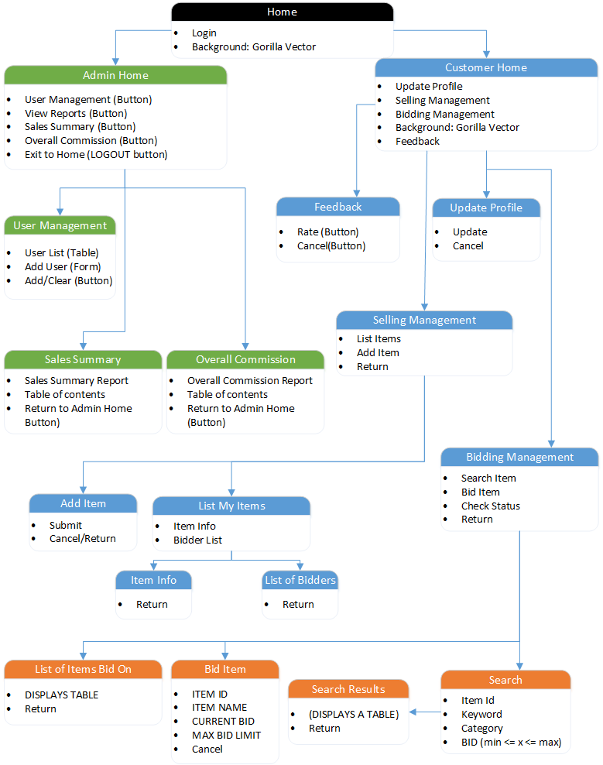

# Part III. The Detailed functionalities of each page

**General User Portal:**

|  |  |
| --- | --- |
| Login to The system  1 functionality:  user login |  |

**Administrator Subsystem: Functionalities for administrators:** (Total of 4 functionalities)

|  |  |
| --- | --- |
| User functionalities (view users, add new user, delete user) | C:\Users\s1lin\AppData\Local\Microsoft\Windows\INetCache\Content.Word\User Management.png |
| User Management Button will lead to this page, which allows the admin to add a new customer by entering basic information: username, first name, last name, email, and password (user id is automatically generated by a system can’t be input by admin.) |  |
| Sales Summary Report lists sales summary information GROUPED by item category, and includes the commission fee received from the sale of each item. The commission report is ordered first by Category name then by ID. | C:\Users\s1lin\AppData\Local\Microsoft\Windows\INetCache\Content.Word\Sales Summary Report.png |

**Customer Subsystem:** (Total of 13 functionalities)

|  |  |
| --- | --- |
| Update Profile allows the user to update and change information about their profile. This includes the ability to change the username, first and last name, email, phone number, and their password. The rating is computed by the system and is a value between 1 and 10. |  |
| The Selling Management page allows users to navigate to a page displaying their personal list of items or a page to add an item. |  |
| The Item List page displays the items this user has posted for sale. |  |
| The Item Information page displays information on the posted item, including item id, name, category, start price, auction start and stop time, and a description of the item. |  |
| The Add Item page allows a seller to add an item to their list to be sold. |  |
| The List of Bidders page displays a list of all bidders for a particular item. It shows the time of the bid, username, bid limit and the winner of the bid. |  |
| The design of the CUSTOMER HOME page is to be a simple, yet tasteful look that will be accompanied by a picture later in the implementation process. It contains all of the functions that will be available to a customer and the buttons will direct the customer to other web-pages that will allow them to do their bidding. |  |
| The BIDDING MANAGEMENT page is designed to allow the customer to search for items that are up for auction, bid on new-to-them items, and check the status of items that they have already bid on. | C:\Users\makounniyom\AppData\Local\Microsoft\Windows\INetCache\Content.Word\BIDDING-MANAGEMENT.PNG |
| The SEARCH page is to have options for the user to search based on the key-elements of items that are up for auction. They are as follows ITEM-ID, KEYWORD, CURRENT-BID (based on **entered-number-1 <= X <= entered-number-2),** AUCTION PERIOD (based on **DATE#1 TO DATE#2**) | C:\Users\makounniyom\AppData\Local\Microsoft\Windows\INetCache\Content.Word\SEARCH-MENU.PNG |
| The SEARCH RESULTS page is displayed after the user attempts a search. The list is generated and displayed above. But in the last few columns are to be hyper-links to an **item information** and **bidding** pages. I could not figure out how to implement them with VISUAL STUDIOS. | C:\Users\makounniyom\AppData\Local\Microsoft\Windows\INetCache\Content.Word\SEARCH-RESULTS.PNG |
| The BID ON ITEM page allows the user to place a bid on the item that they clicked on which brought them to here. It displays the item ID, Item Name, Current Bid, and Max Bid Limit for the item that they are trying to bid on. | C:\Users\makounniyom\AppData\Local\Microsoft\Windows\INetCache\Content.Word\BID-ON.PNG |
| The LIST OF ITEMS BOUGHT page is brought to you by the “LEAVE FEEDBACK” button from the menu page. It displays all of the necessary information for an item, such as ID, NAME, CATEGORY, AUCTION START AND END, START PRICE, SOLD PRICE, SELLER USERNAME, SELLER EMAIL. It allows the user to click on a link that will reside in the RATE SELLER column which will lead them to the LEAVE FEEDBACK page. | C:\Users\makounniyom\AppData\Local\Microsoft\Windows\INetCache\Content.Word\LIST-ITEMS-BOUGHT.PNG |
| The page LIST OF ITEMS BID ON shows the items that the user has already bid on. The information displayed is ID, NAME, CATEGORY, AUCTION START AND END, START PRICE, WINNER. |  |
| The LEAVE FEEDBACK page allows the user to leave feedback for the desired seller. This page displays the ITEM ID, ITEM NAME, OVERALL RATING, ITEM QUALITY, DELIVERY, AND COMMENTS. | C:\Users\makounniyom\AppData\Local\Microsoft\Windows\INetCache\Content.Word\FEEDBACK-SCREEN.PNG |

# Part IV. Highlight Problems:

* The GUI is hard to draw by limited time and resources.
* Hard to commit time.

# Part V. Detailed Task Decomposition

* Shilei: For interface Map Diagram, I did the part of Administrators, and the details of each functionalities.
* Josh: I helped work on the User Interface Map Diagram by doing the Selling Management, Update Profile, Add Item, List Items, Item Info, and List of Bidders pieces. I also made the User Interface sketch for each of these pages.
* Matthew: The parts of which that I designed for the User Interface Map Diagram and did sketches for the User Interface were the Customer Home, Bidding Management, Search & Search Results, Item Bid, List of Items Bid on, and the Browse Feedback/Leave Feedback pages.

# Part VI. Detailed Meeting Minutes

|  |  |
| --- | --- |
| September 1st | We sat there and designed our user interface map diagrams for our system.  Came up with a team name. We all took turns talking and drawing our visualized diagrams with MICROSOFT VISIO 2016. |
| September 9th | we drew sketches for the interface diagrams and wrote the descriptions for each page. |
| September 11th | We drafted the report and updated our MS VISIO Interface Map Diagram. |